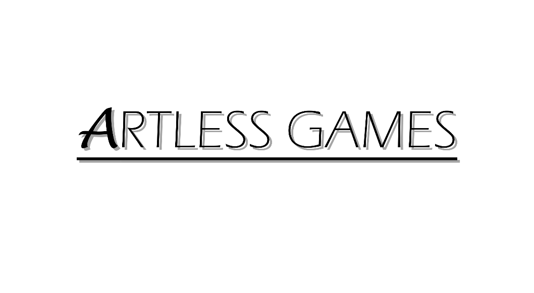

**COLD NITES**

Alpha-1

**Base Grid Character Design Document**

Designed & Implemented by

Yash Chamria

**Change Log**

**Version** – 0.1

**Modifier** – Yash Chamria

**Date** – 16th March, 2021

**Description** – Created the Design Document.

**Table of Contents**

1. **Introduction 4**
2. **Design Goals 5**
3. **System Overview and Behaviour 6**
4. **Logical View 7**

**A. High-Level Design Architecture of the Entire System**

**B. Mid-Level Design of TileMap System**

**C. Detailed Design of TileMap System**

1. **Process View 11**
2. **Use Case View and Practice 12**

**1. Introduction**

Cold Nites is a Grid-style turn-based game. The player must strategically navigate through the level to survive the cold night, protecting the boy from all the mischievous elements of the city. And, there are always multiple ways to solve the puzzles along the way.

**2. Design Goals**

The design priorities for the BaseGridCharacter are mentioned below:

**3. System Overview and Behaviour**

**4. Logical View**

The logical view describes the high-level architecture for the entire game from all the core classes to high-level relations and interactions between them with a flow chart making it easy to read and understand.

Later, it will dive deep into the high-level and detailed design for the TileMap Module, using a UML Class Diagram.

**A. High-Level Design Architecture of the Entire System**

The primary features for the Alpha 1 release:

1. **TileMap** - TileMap provides the grid-based behaviour for the game and will facilitate the event system, based on the actor present on the Tiles.
2. **Turn-Based System** - This provides the turn-based aspect for the game. It is responsible for maintaining the turn order for all the world elements(actors) and the player.
3. **Base Grid Character** –
4. **Player Character** - Player is a controllable character that inherits from BaseGridCharacter, which takes user inputs to perform appropriate moves.
5. **Inventory System** - Inventory stores the item for the corresponding actor and will allow the player easy access to any collectible throughout the game.
6. **User Interface** - The User Interface will be responsible for Main Menu and any in-game HUD (or User Widget) with which the player can interact.

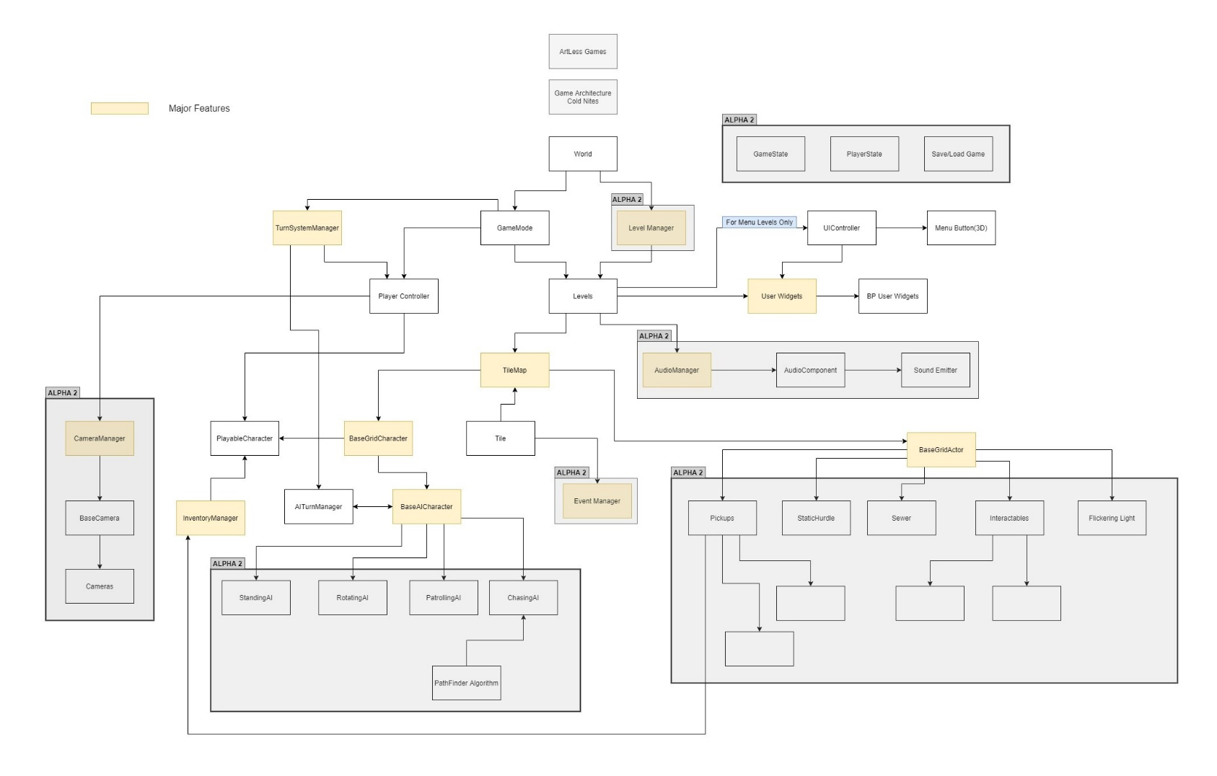

**B. Mid-Level Design of TileMap System**

**C. Detailed Design of TileMap System**

**5. Process View**

The process view will explain the relation and interaction between various cases using Sequence and Collaboration Diagrams.

**6. Use Case View and Practice (Application)**

The use case will focus on showing the uses of Base Grid Character at different stages in the game and will explain its application so that this module can act as a guide/reference for someone not quite familiar with the BaseGridCharacter codebase.